**Groupe 1**

**Serginau LOUIS**

**Chasnick DESIR**

**Hardiles THERMORIS**

**Chrismond VERSAILLES**

**BOUTIQUE ANALYSIS**

**1.Recognize the business problem**

**What is the business problem?**

At the moment, Michel finds himself in a dilemma with his shop more specifically in the field of selling tomato paste. He doesn't know if he should keep selling them or not.

Reason: tomato paste could not be sold in proportion to the pace of purchases

As a group of data analysts, we will analyze the store's last three months data in order to advise Michel on the best decision.

**Who are the stakeholders impacted by the problem?**

The different parts affected by this problem are

* Michel (The owner): he has invested and he is currently in a situation of flight of his capital.
* Michel's son: through his links with the owner, he is directly affected by the loss of the family patrimony
* Customers: Although not directly concerned by the problem of the sale of tomato paste, customers could find themselves affected by a non-availability of the product in their immediate surroundings.
* The Provider: The provider (s) can be impacted by this problem because Michel has been one of their customers. If Michel can no longer sell his orders, the Provider(s) will simply stop the orders and will suddenly lose one of their clients.

**Why is the problem significant to the organization?**

The problem is important because it affects the profitability of the company. If the losses are not contained, the company might abandon the market of tomato paste.

**2.Research the organization**

Any commercial or industrial enterprise aims to maximize its profit.

Although we do not have precise data on the values ​​shared by the company, we can with a certain level of reasonable confidence think that the boutique company has as values:

-integrity.

-Honesty

-Team spirit.

Here too, we face a lack of data, but we can reasonably assume that the Boutique business defines its success in relation to its level of sales.

The more profitably he sells, the more successful he is.

The business presumably has relationships with suppliers and everyone who maintains a relationship with those suppliers.

**3.Identify your client**

The client who hired us to do this work, determining whether or not to continue selling tomato paste, is the son of the store owner. He is the operations and sales manager of the company. What motivated him to contact us is that he is concerned about the losses due to his tomato paste stock management, since the last three months there is no profit on the sale of tomato paste and every month a lot of products are wasted, he wants to know if he should continue to sell the usual products but changing the strategy of buying and selling tomato paste or if he should stop selling it.

**4.Identify relevant stakeholder:**

**Stakeholder Analysis:**

|  |  |  |  |  |
| --- | --- | --- | --- | --- |
| **Stakeholders** | **Interest and expectation** | **Position** | **management plan** | **Reaction(+/-)** |
| **Michel** | * Income/profits * Capital increase. | **Owner** | * Eliminate the loss on the sale of tomato paste. | **Positive** |
| **Michel’s son** | Adaptation to change, adjustment and consistency of resource management | **Operations & Sales Manager** | * To define a new strategy for the purchase, storage and sale of tomato paste. | **Positive** |
| **The supplier** | * Increase the purchase price. * Increase sales volume. | **None** | * Reduce the number of orders and keep the same recurrence, then pay on time. | **Mitigated** |
| **The client** | * Be able to satisfy your needs with one of their store's products | **None** | * Make sure he always finds the product he wants so that we always have his confidence. | **Mitigated** |

**Explanation on the reactions of the stakeholders:**

- Mr. Michel the owner, through the solution, we will help him increase his wealth because we will either reduce or eliminate the loss on the sale of tomato paste.

- For Mr. Michel's son, the strategy we will propose will allow him to optimize his storage and management policy within the company.

- The supplier's reaction to our work is rather mixed in the sense that if we adopt Mr. Michel's and his son's plan, he risks losing a customer, which will reduce his sales volume, so his reaction would be negative; if we continue to do business with the supplier, the store risks reducing the volume of orders, which is certainly not the result the supplier is aiming for, but all the same, he will keep the store among his customers.

- The customer, the reaction of the customer is also mixed since he risks not being able to satisfy his need in tomato paste but if we adopt a solution that will allow them to always have access to the desired product he will have a positive reaction towards our work so basically the customer has a mixed reaction because he doesn't know where to find our work.   
**5.Create a conceptual model**

For our analysis we will use different methods who are able to show us the best alternative solutions.

As you know in accounting science, 2 methods are available when you want to manage a stock.

FIFO: First In First Out

LIFO: Last In First Out

We will do the comparison between both and after we will be able to advise Michel the best stock managing solution.

After that, we calculate the rate of growth sales and after we do the mean of rate. This will facilitate us to anticipate the sales and scientifically know evaluate the level command that Michel needed.

Michel gave us the data and we will base all of our reflection on this after the cleaning operation.

***The tables are in the Dataset, sheet Reports.***

**SWOT METHODOLOGY ANALYSE**

|  |  |
| --- | --- |
| STRENGTH | WEAKNESSES |
| * Sells different brands of tomato paste. * Regular supply. * Have a sales and inventory register adapted to the context. | * The products have a fairly short expiration date which reduces our reaction time. * Lack of knowledge of customer preferences. * A poor management in supplying |
| OPPORTUNITIES | THREATS |
| * This is the perfect opportunity for the company to adopt a new tomato paste inventory management strategy that is better suited to its situation. * The boutique owner can adjust his stock to demand. * Conduct a survey to know what the client really wants. * opportunity for michel's store to absorb all his debts on the sale of tomato paste in the coming years. | * Any mistake in our management strategy can cause great loss. * Due to the fact that the store does not have a real knowledge of the customer's preferences, it is difficult for us to keep them. |

**6.Develop alternative solutions**

Our solution will affect all of the relevant stakeholders such as Michel, Michel son, provider.

It will cost nothing for Michel and Michel son except our salary.

The risk will be on the supplier side because it will be hardly affected by Michel's decision.

The solution implementation will take less than 2 days but Michel will see the results only after one months and more.

**There is some graphics to facilitate the understanding of the proposed solutions**

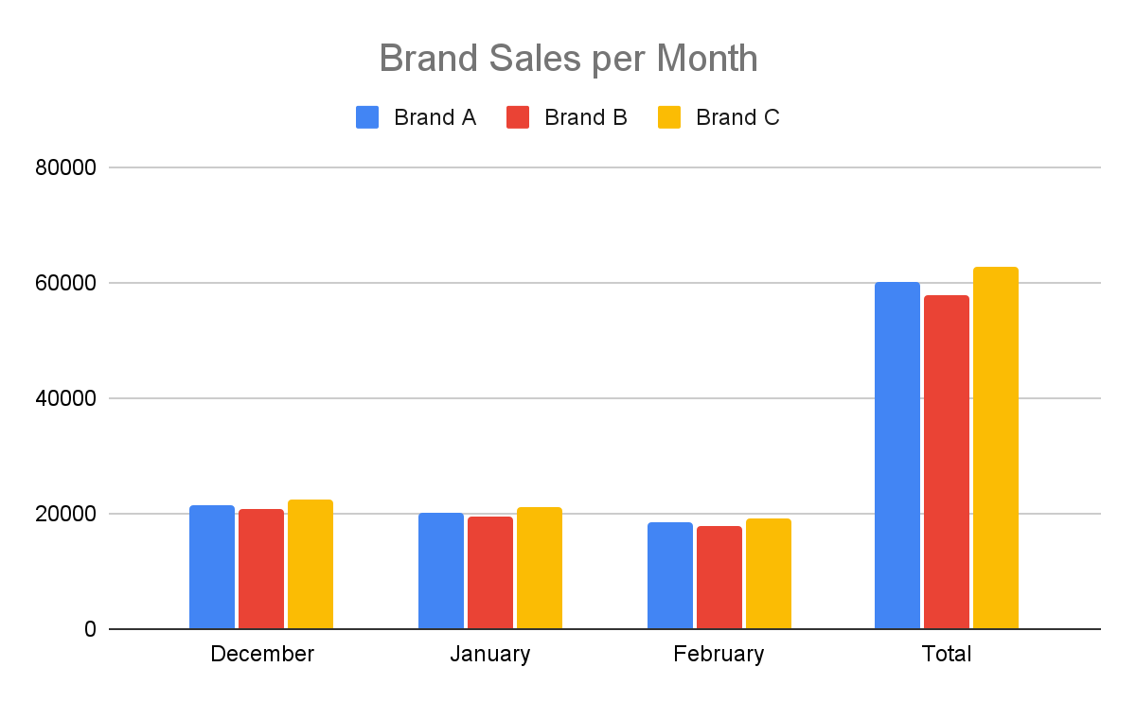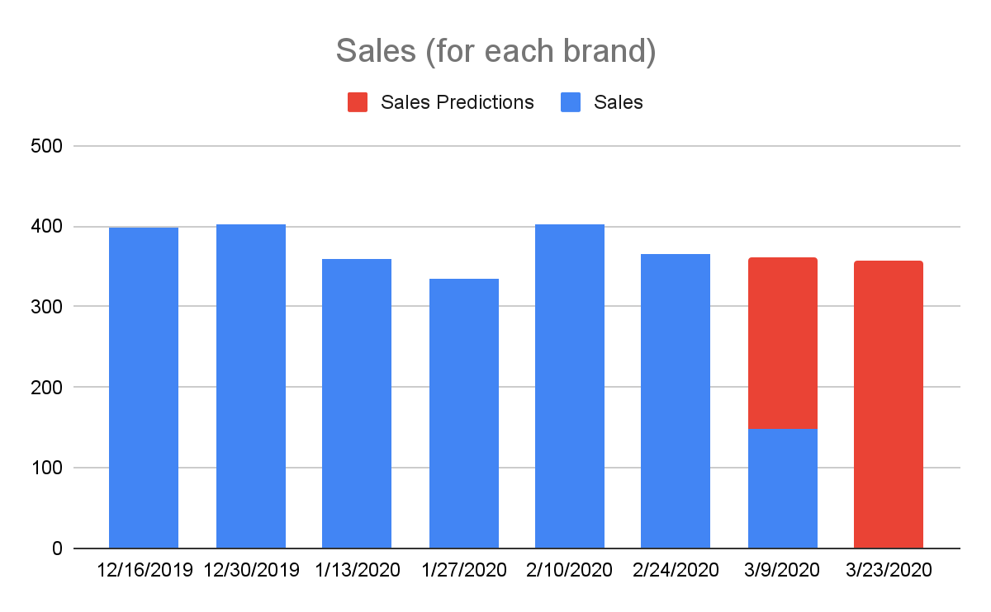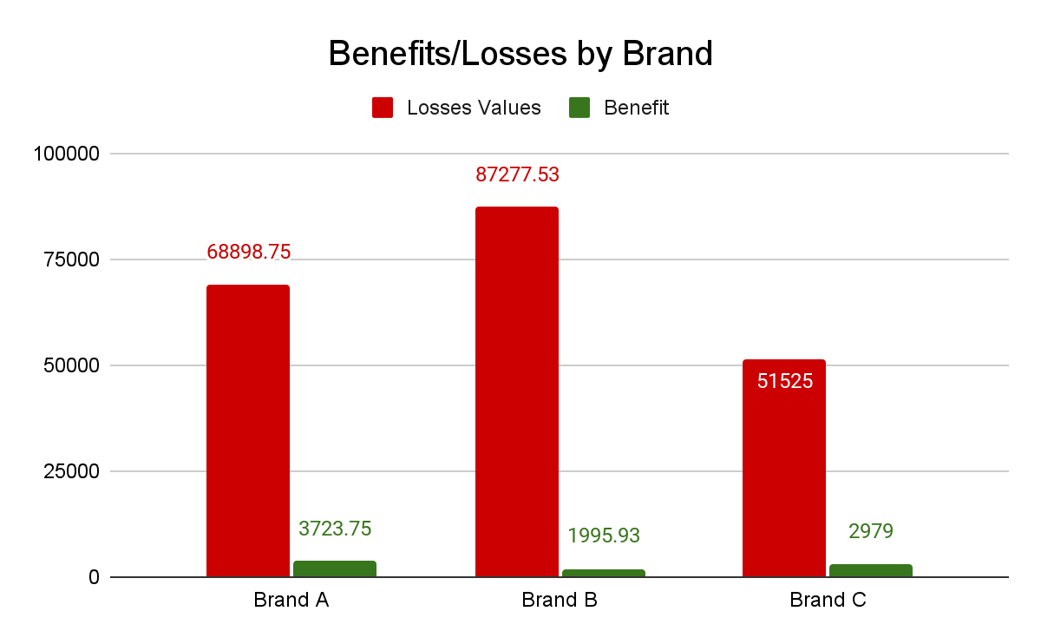

**7.Present the Solution**

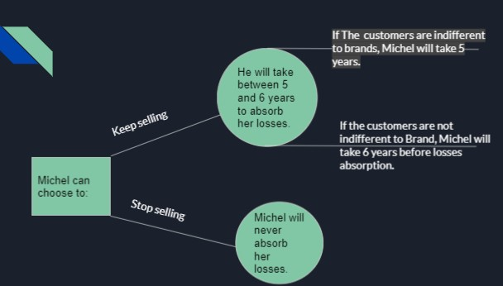

After all data processing, we are now able to give our recommandation.

**1-What caused such a situation?**

Our actual situation is due to a greater volume order than the sales capacity of the company and a very bad stock management modal.

**2-What can we do to solve this problem?**

We can implement two solutions depending on our constraints.

Before all, he must stop their orders for the next 23 days.

If Michel has constraints in the costs of orders ,it will be easier for him to do only one order per month. her volume will depend on our prediction with a security merge.

we can take a merge security equal to 10% of sales.

If Michel haven’t constraints on her cost command he can decide to receive two orders per month but he will have to reduce the volume of his orders by around 53%.

We also advise Michel to sell 2 cans of tomatoes for a price of one.This will permit Michel to reduce Losses by 20%.

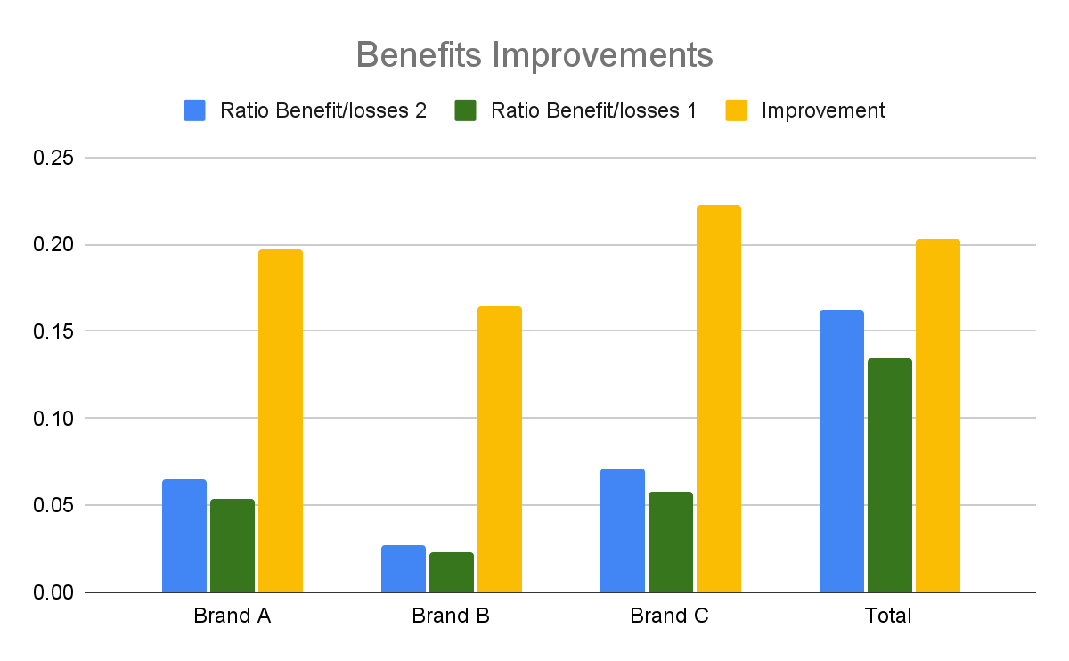

If Michel wants to absorb the losses suffered, he can do 2 things:

A-If the customers are indifferent to the brand, Michel may decide to sell only the brand A boxes because he has a higher profit ratio on that brand.

And then it will take 5 years before completely absorbing the losses.

B-If the customers are not indifferent to the brand, Michel can decide to sell a combination of 3 brands in the same proportions and then it will take him around 6 years 6 months to absorb the losses.

